Tabari Harvey 01/10/2025 Module 2.2 Assignment Debugging

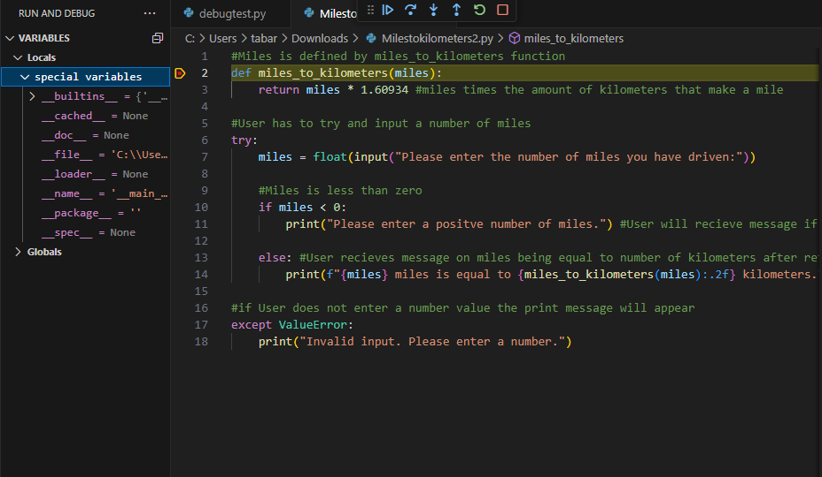

1. The breakpoint
2. 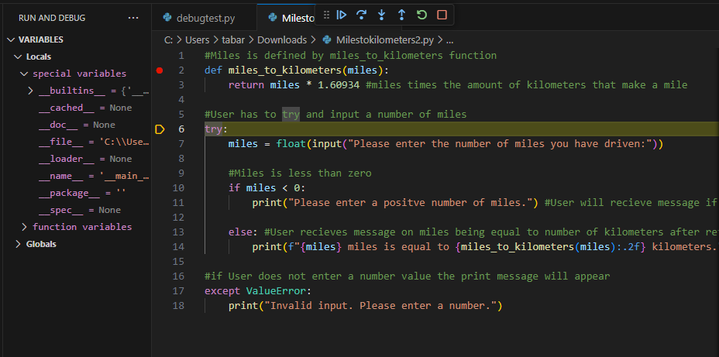

The first Stepover

1. 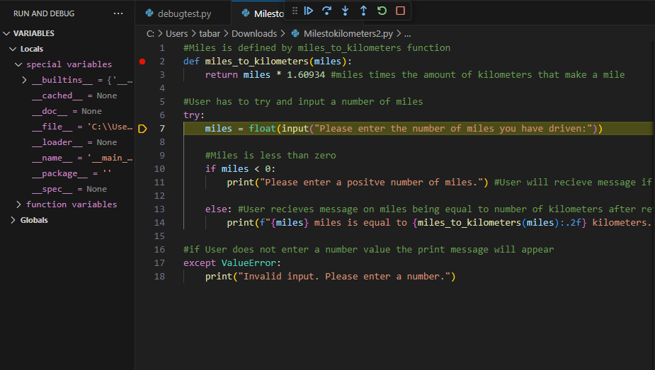

The second stepover which then ended after hitting it again.

1. 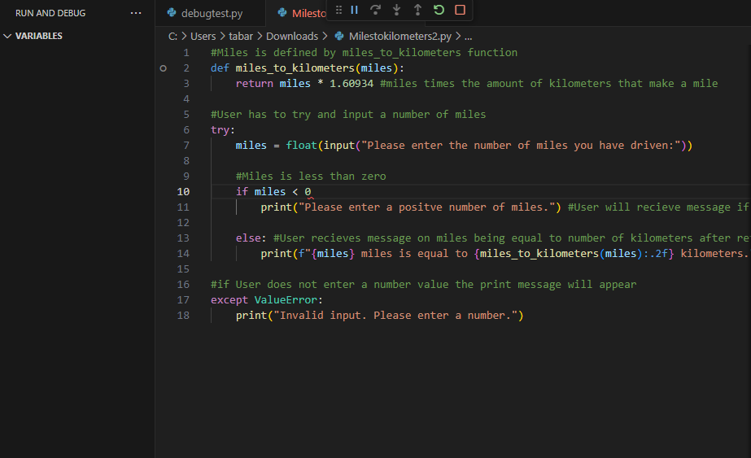

In the if statement, I took out the colon and when I hit stepover again the debug stopped and I lost all variables on the left. The program immediately stopped to let me know this was a syntax error.